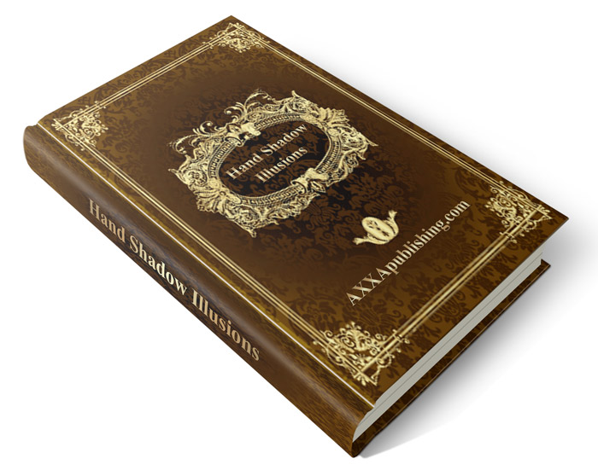
Hand Shadows Illusions
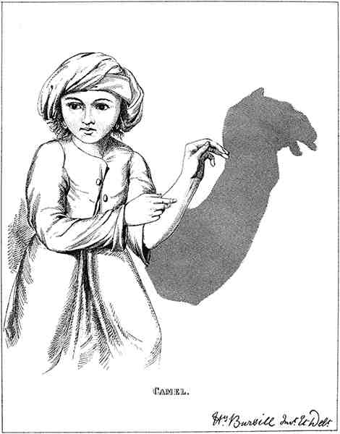

A SERIES OF NOVEL AND AMUSING FIGURES
FORMED BY THE HAND

PREFACE
I need not explain how these Shadows were suggested, to any one who has seen WILKIE'S picture, "The Rabbit on the all."

But by what pains they were invented can never be revealed; for it is known to my tortured digits alone, and they, luckily for me, are dumb. I calculate that I put my ten fingers through hundreds of various exercises before my "Bird" took wing; my left little finger thrills at the memory of "Grandpapa"; and my thumbs gave in no less than twenty times before "Boy" was accomplished.

Yet now how easy it is to make the "Duck" to quack, the "Donkey" to bray, "Toby" to wag his tail, and the "Rabbit" to munch his unsubstantial meal.

Of course the Shadows are not to be reproduced perfectly, on "one trial only"; but I believe that in each case I have drawn the due position of the fingers with such care, that the most difficult subject may be accomplished after a few minutes; nor need ingenious youth or parental fondness confine their endeavours to the sketches contained in this book. With a little ingenuity and some patience, new shadows may be produced; and not unfrequently figures appear that one never dreamed of attempting.

Other Books of Shadows have been published; but it will be seen at a glance that mine bears affinity to none.

Some of my sketches were made years ago, others when a student at the Academy.

Indeed, the Shadows have often been displayed on the walls of my studio, much to the amusement of fellow-

.
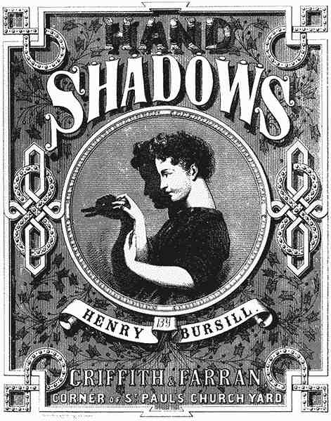

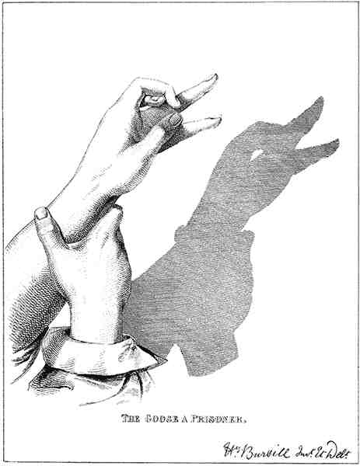

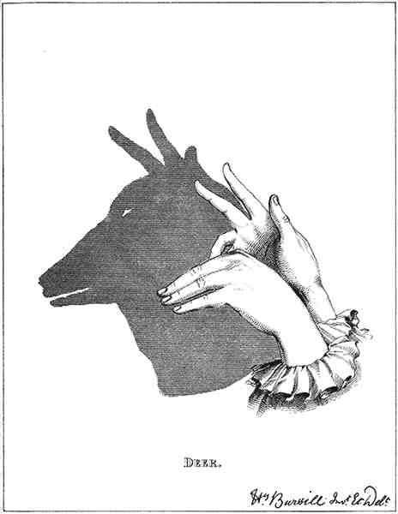

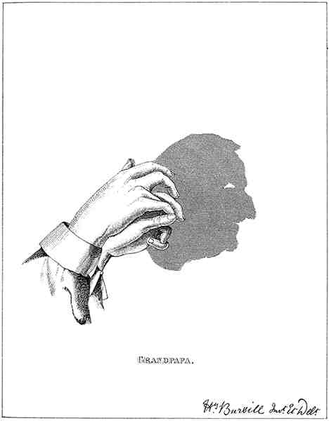

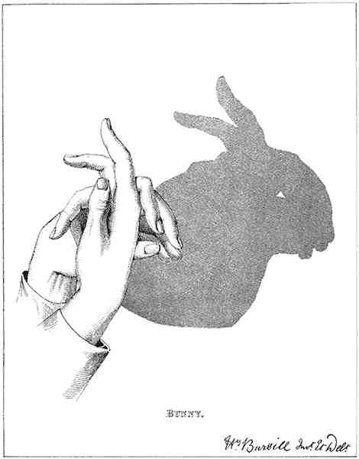

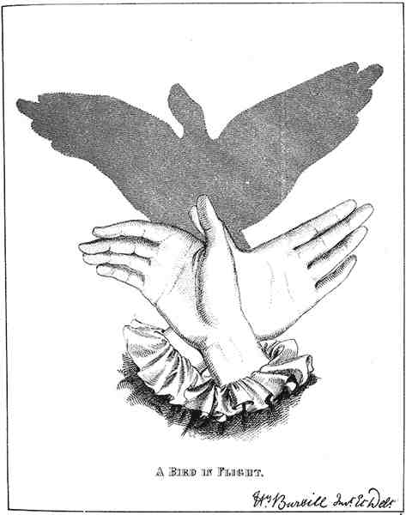

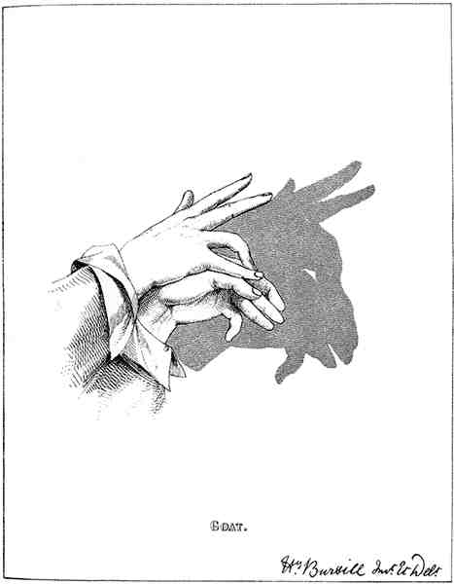

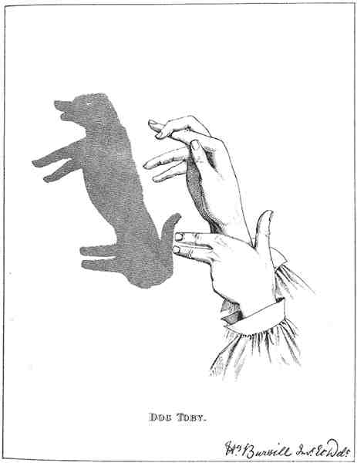

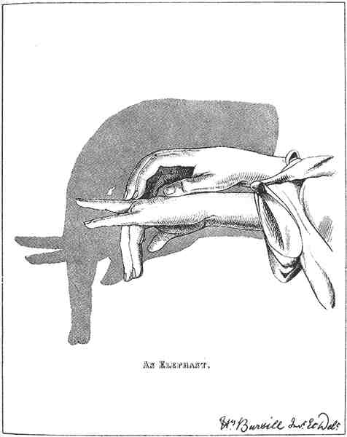

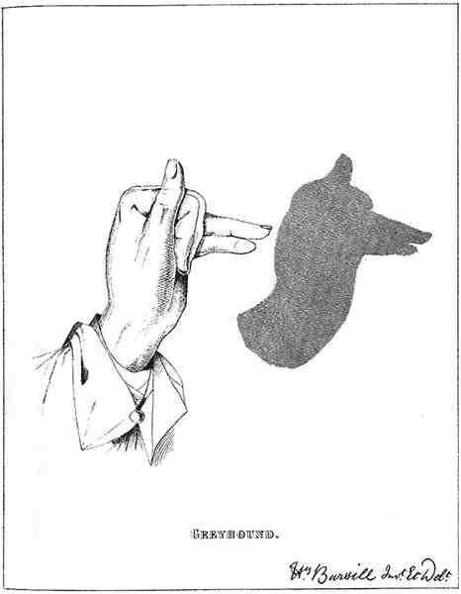

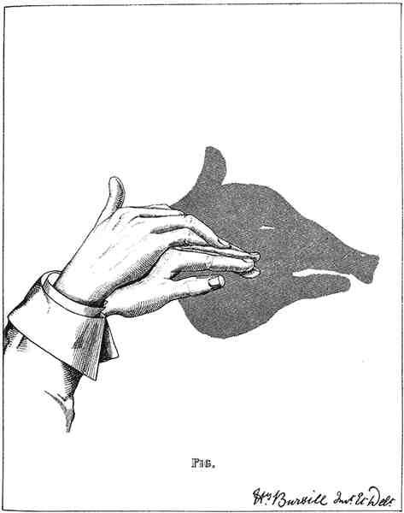

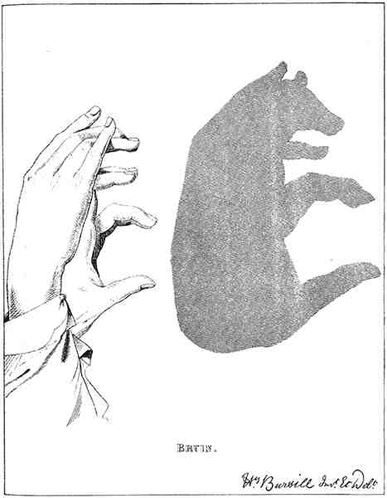

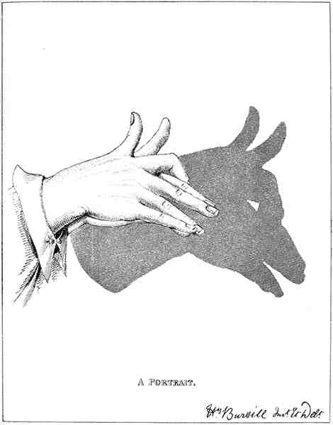

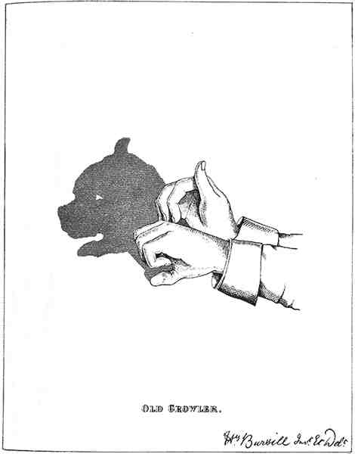

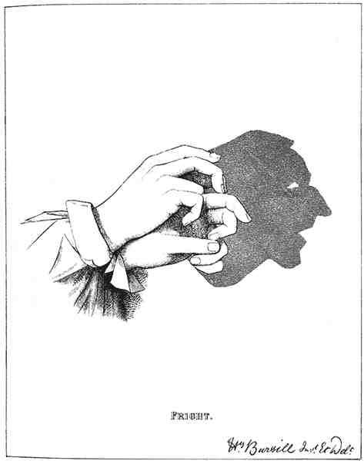

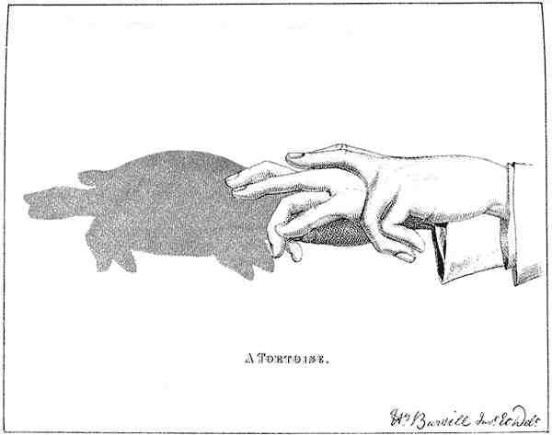

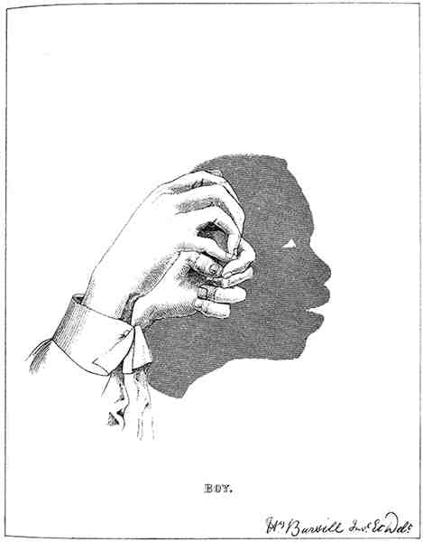

THE END

